

**SANDIPUNIVERSITY,SIJOUL**

# SchoolofComputerScience&Engineering

**CourseNameandCode:** DSA Lab MCA207P **Class:**B.TECH3rdYear**Session:**2024-2026 **Semester:**IInd

**LISTOFEXPERIMENT**

|  |  |  |
| --- | --- | --- |
| **S.NO.** | **NAMEOF EXPERIMENTS** | DATEOF  EXPERIMENTS |
| **01.** | **Developacomplete webpage usingHTMLbasictags.**  Asimplewebpagethatincludesbasictagssuchashead,body,textformattingtags,lists,paragraph,table,and image tags. |  |
| **02.** | **Develop A web pageusing CSS, andLayout**  AlayoutincludesHeader,Footer,Navigation,Article,etc. |  |
| **03.** | **DesignawebpageusingJavaScripttodemonstrate,ifstatement,if...else statementandSwitchstatement.**  AsimplewebpagethatincludeJavaScriptstatementssuchas if,if...else and switch. |  |
| **04.** | **DesignawebpageusingJavaScripttodemonstrateAlert Box, alert box with line breaks, confirm box and prompt box**  AsimplewebpagethatincludeJavaScriptalert box, alert box with line breaks, confirm box and prompt box. |  |
| **05.** | **DesignawebpageusingJavaScript to demonstrate call a function, function with an arguments, function that return a value.**  AsimplewebpagethatusingJavaScript to demonstrate call a function, function with an arguments, function that return a value. |  |
| **06.** | **Design a web page using JavaScript to demonstrate use of loops**  A simple web page that include JavaScript for loops, while loop, do-while loop, loop a break, break & continue loop |  |
| **07.** | **Design a web page using JavaScript to demonstratesorting of an array**  A simple webpage that include JavaScript to sort an array alphabetically and ascending |  |
| **Group B** | |  |
| **01** | **DesignawebpageusingPHPtodemonstrate,variables, echo/print, data types, string functions andoperators.**  AsimplewebpagethatincludePHPvariables,echo/print, datatypes,string functionsandoperators. |  |
| **02** | **Design a web page using PHP to demonstrate conditional statement and loops**  A simple web page that include PHP if if –else, else_if,switch, for loop, while loop. |  |
| **03** | **Webserverinstallationandconfiguration**  InstallationandconfigurationofanywebserverlikeIIS,Apache,WAMP, XAMP, LAMP etc. |  |
| **04** | **DesignawebpageusingPHPtodemonstrate Date, file, coockies and sessions.**  A simple web page that include PHP Date, file, cookies and sessions. |  |
| **05** | **DesignawebpageusingPHPtodemonstrateMySQLconnectivity.**  SimplewebpagesthatincludePHPMySQLconnect, CreateDB/Table,insert into,select,updateanddelete. |  |
| **06** | **Design a website with the help of HTML and JavaScript/php (commercial, institute, portal or decided jointly by the student and teacher)**  Design a website on above mentioned topics with the help of HTML and JavaScript/PHP. |  |



**SANDIPUNIVERSITY, SIJOUL**

# School of Computer Science& Engineering

### Name of Student: PRN:

**Date of Performance: Date of Completion:**



**ExperimentNo: 01**

**Aim:** Loading and Exploring a Dataset (e.g., Iris, MNIST) Using Pandas and Calculating Summary Statistics

**Objective:**

* To learn how to load datasets (Iris and MNIST) into Python using the Pandas library.
* To explore the structure and content of the datasets.
* To calculate and interpret summary statistics (e.g., mean, median, standard deviation) for the datasets.

**Prerequisites**

* **Software**: Python 3.x installed with the following libraries:
  + pandas
  + numpy
  + scikit-learn (for Iris)
  + tensorflow or keras (for MNIST, optional for raw data loading)
* **Hardware**: A computer with sufficient memory (at least 4GB RAM recommended).
* **Skills**:
  + Basic Python programming knowledge.
  + Familiarity with installing Python libraries using pip (e.g., pip install pandas numpy scikit-learn).
* **Dataset Availability**:
  + Iris dataset (built into scikit-learn).
  + MNIST dataset (available via tensorflow.keras.datasets or as raw CSV files).

**Theory**

* **Pandas**: A powerful Python library for data manipulation and analysis, providing data structures like DataFrames.
* **Iris Dataset**: A classic multivariate dataset with 150 samples of 4 features (sepal length, sepal width, petal length, petal width) and 3 species classes.
* **MNIST Dataset**: A large database of handwritten digits (0–9) with 70,000 images (28x28 pixels each), often used for machine learning.
* **Summary Statistics**: Descriptive measures (e.g., mean, median, min, max) that summarize the central tendency, dispersion, and shape of a dataset’s distribution.

**Apparatus/Software Requirements**

* Python IDE or Jupyter Notebook.
* Internet connection (for initial library installation).

**Procedure**

**Step 1: Set Up the Environment**

1. Install required libraries if not already installed:

pip install pandas numpy scikit-learn tensorflow

2. Launch Jupyter Notebook or your preferred Python environment.

### Step 2: Load the Iris Dataset

1. Import necessary libraries.
2. Load the Iris dataset using scikit-learn.
3. Convert it to a Pandas DataFrame for analysis.

### Step 3: Explore the Iris Dataset

1. Display the first few rows of the dataset.
2. Check the dataset’s shape, column names, and data types.
3. Calculate summary statistics.

### Step 4: Load the MNIST Dataset

1. Import the MNIST dataset using tensorflow.keras.datasets.
2. Preprocess the data (e.g., flatten images) and create a DataFrame.
3. Explore the dataset and calculate summary statistics.

### Step 5: Analyze and Interpret Results

1. Compare summary statistics between Iris and MNIST.
2. Document observations (e.g., range of values, missing data).

**Program Code**

**Lab Program: Loading and Exploring Datasets with Pandas**

**Import libraries**

import pandas as pd

import numpy as np

from sklearn.datasets import load_iris

from tensorflow.keras.datasets import mnist

**Step 1: Load and Explore Iris Dataset**

print("=== Exploring Iris Dataset ===")

**Load Iris dataset**

iris = load_iris()

iris_df = pd.DataFrame(data=iris.data, columns=iris.feature_names)

iris_df['target'] = iris.target

**Display first 5 rows**

print("First 5 rows of Iris dataset:")

print(iris_df.head())

**Check dataset info**

print("\nDataset Info:")

print(iris_df.info())

**Calculate summary statistics**

print("\nSummary Statistics for Iris dataset:")

print(iris_df.describe())

**Step 2: Load and Explore MNIST Dataset**

print("\n=== Exploring MNIST Dataset ===")

**Load MNIST dataset**

(X_train, y_train), (X_test, y_test) = mnist.load_data()

**Flatten images and create DataFrame (using first 1000 samples for simplicity)**

mnist_df = pd.DataFrame(X_train.reshape(X_train.shape[0], -1)[:1000])

mnist_df['label'] = y_train[:1000]

**Display first 5 rows**

print("\nFirst 5 rows of MNIST dataset:")

print(mnist_df.head())

**Check dataset info**

print("\nDataset Info:")

print(mnist_df.info())

**Calculate summary statistics (for pixel values)**

print("\nSummary Statistics for MNIST dataset (pixel values):")

print(mnist_df.drop(columns=['label']).describe())

**Expected Output**

Iris Dataset

First 5 rows of Iris dataset:

sepal length (cm) sepal width (cm) petal length (cm) petal width (cm) target

0 5.1 3.5 1.4 0.2 0

1 4.9 3.0 1.4 0.2 0

2 4.7 3.2 1.3 0.2 0

3 4.6 3.1 1.5 0.2 0

4 5.0 3.6 1.4 0.2 0

**Summary Statistics**:

* Mean sepal length: ~5.84 cm
* Min petal width: 0.1 cm
* Max petal length: 6.9 cm

### MNIST Dataset

* **First 5 Rows** (partial view of flattened 28x28=784 pixels + label):

First 5 rows of MNIST dataset:

0 1 2 ... 783 label

0 0 0 0 ... 0 5

1 0 0 0 ... 0 0

2 0 0 0 ... 0 4

3 0 0 0 ... 0 1

4 0 0 0 ... 0 9

**Summary Statistics** (for pixel values, 0–255 range):

* Mean: ~30–40 (varies by sample subset)
* Min: 0
* Max: 255

**Observations**

* **Iris**: The dataset has 150 rows and 5 columns (4 features + target). All features are numeric with no missing values. Summary statistics show a range of values typical for flower measurements.
* **MNIST**: The dataset has 60,000 training images (subset to 1000 here), with 784 pixel features per image. Pixel values range from 0 (white) to 255 (black), with labels 0–9.

**Conclusion**

This lab demonstrated how to load and explore the Iris and MNIST datasets using Pandas. Summary statistics provided insights into the data’s distribution, preparing the ground for further analysis (e.g., machine learning).

**Viva question:**

1. What differences do you notice in the summary statistics between Iris and MNIST?
2. How might missing values or outliers affect the summary statistics?
3. Suggest a way to visualize the Iris dataset’s features (e.g., scatter plot).

**NAMEOFTEACHER:**

### DATE:

**SIGN**



**SANDIPUNIVERSITY,SIJOUL**

# SchoolofComputerScience&Engineering

### NameofStudent: PRN:

**DateofPerformance: DateofCompletion:**



**ExperimentNo.:02**

### ****Stack - Check for Balanced Parentheses****

**Concept:**A stack is a linear data structure that follows the Last In First Out (LIFO) principle. It is often used for problems like checking balanced parentheses in an expression.

#### ****Objective:****To check whether the parentheses in an expression are balanced using a stack.

#### ****Theory:****A stack follows the **Last in First out (LIFO)** principle. For balanced parentheses, each opening parenthesis (must be matched with a closing parenthesis). This can be efficiently solved using a stack by pushing each opening parenthesis onto the stack and popping when a closing parenthesis is encountered.

#include <stdio.h>

#include <stdlib.h>

#include <string.h>

#define MAX 100

char stack[MAX];

int top = -1;

void push(char c) {

if (top < MAX - 1) {

stack[++top] = c;

}

}

char pop() {

if (top == -1) {

return -1;

}

return stack[top--];

}

int is_balanced(char *expression) {

for (int i = 0; expression[i] != '\0'; i++) {

if (expression[i] == '(') {

push(expression[i]);

} else if (expression[i] == ')') {

if (top == -1 || pop() != '(') {

return 0;

}

}

}

return top == -1;

}

int main() {

char expression[] = "(a + b) * (c + d)";

if (is_balanced(expression)) {

printf("Expression is balanced\n");

} else {

printf("Expression is not balanced\n");

}

return 0;

}

**Output:**

Expression is balanced

**NAMEOFTEACHER:**

### DATE:

**SIGN**



**SANDIPUNIVERSITY,SIJOUL**

# SchoolofComputerScience&Engineering

### NameofStudent: PRN:

**DateofPerformance: DateofCompletion:**



**ExperimentNo.:03**

**Queue - Implement a Simple Queue Using Arrays**

#### ****Concept:****A queue is a linear data structure that follows the First in First out (FIFO) principle. Elements are added at the rear and removed from the front.

#### ****Objective:****To implement a queue using an array and perform basic operations like en-queue and de-queue.

#### ****Theory:****A ****queue**** is a linear data structure that follows the ****First in First out (FIFO)**** principle. It allows elements to be inserted at the rear and removed from the front. It is used in scenarios where ordering and scheduling are important, like in CPU scheduling.

**Program**

#include <stdio.h>

#define MAX 5

int queue[MAX];

int front = -1, rear = -1;

void enqueue(int value) {

if (rear == MAX - 1) {

printf("Queue is full\n");

} else {

if (front == -1) front = 0;

queue[++rear] = value;

}

}

void dequeue() {

if (front == -1) {

printf("Queue is empty\n");

} else {

printf("Dequeued: %d\n", queue[front]);

if (front == rear) {

front = rear = -1;

} else {

front++;

}

}

}

void display() {

if (front == -1) {

printf("Queue is empty\n");

} else {

for (int i = front; i <= rear; i++) {

printf("%d ", queue[i]);

}

printf("\n");

}

}

int main() {

enqueue(10);

enqueue(20);

enqueue(30);

display();

dequeue();

display();

return 0;

}

### Output:

### 10 20 30

### DE queued: 10

### 20 30

### NAMEOFTEACHER:

**DATE:**

**SIGN**



**SANDIPUNIVERSITY,SIJOUL**

# SchoolofComputerScience& Engineering

### NameofStudent: PRN:

**DateofPerformance: DateofCompletion:**



**ExperimentNo.:04**

### ****Binary Search Tree (BST) - Insert and Search****

#### ****Concept:****A Binary Search Tree (BST) is a tree data structure where each node has at most two children, and for each node, its left child is smaller, and its right child is larger.

#### ****Objective:****To insert elements into a Binary Search Tree (BST) and search for an element.

#### ****Theory:****A **Binary Search Tree (BST)** is a tree in which each node has at most two children. For each node, the left subtree contains only nodes with values less than the node's value, and the right subtree contains nodes with values greater than the node’s value. This structure allows efficient searching, insertion, and deletion.

**Program**

#include <stdio.h>

#include <stdlib.h>

// Define a node of the tree

struct Node {

int data;

struct Node *left, *right;

};

// Function to create a new node

struct Node* newNode(int data) {

struct Node* node = (struct Node*)malloc(sizeof(struct Node));

node->data = data;

node->left = node->right = NULL;

return node;

}

// Insert function to add a node to the BST

struct Node* insert(struct Node* root, int data) {

if (root == NULL) return newNode(data);

if (data < root->data) {

root->left = insert(root->left, data);

} else if (data > root->data) {

root->right = insert(root->right, data);

}

return root;

}

// Search function to find a node in the BST

int search(struct Node* root, int key) {

if (root == NULL) return 0;

if (root->data == key) return 1;

if (key < root->data) return search(root->left, key);

return search(root->right, key);

}

int main() {

struct Node* root = NULL;

root = insert(root, 50);

insert(root, 30);

insert(root, 20);

insert(root, 40);

insert(root, 70);

insert(root, 60);

insert(root, 80);

if (search(root, 40)) {

printf("40 is found in the BST.\n");

} else {

printf("40 is not found in the BST.\n");

}

return 0;

}

### Output:

### 40 is found in the BST.

### NAMEOFTEACHER:

**DATE:**

**SIGN**



**SANDIPUNIVERSITY,SIJOUL**

# SchoolofComputerScience&Engineering

### NameofStudent: PRN:

**DateofPerformance: DateofCompletion:**



**ExperimentNo.:05**

**Title**:Design a web page using PHP to demonstrate, variables, echo/print, data types, string functions andoperators**.**

**Objective: A** simple web page that include PHP variables, echo/print, data types, string functions andoperators**.**

**THEORY:**

* PHP is an acronym for "PHP: Hypertext Preprocessor".
* PHP is a widely-used, open-source scripting language.
* PHPscriptsareexecutedon the server.
* PHPisfree to downloadand use.
* PHPfilescancontaintext,HTML, CSS, JavaScript,andPHPcode
* PHP code is executed on the server, and the result is returned to the browser as plain

**PHPVariables**

InPHP,avariablestartswiththe$sign.

**PHPechoandprintStatements**

Echoandprintaremore orlessthesame.Theyarebothused tooutputdatatothescreen.

The differences are small: echo has no return value while print has a return value of 1 so it can be used inexpressions. Echo can take multiple parameters (although such usage is rare) while print can take oneargument.Echoismarginally faster than print.

**PHP DataTypes**

Variablescanstoredataofdifferenttypes,anddifferentdatatypescandodifferentthings.

* String
* Integer
* Float(floatingpointnumbers -alsocalleddouble)
* Boolean
* Array
* Object
* NULL
* Resource

**PHPStrings**

strlen()-ReturntheLengthofaString

ThePHPstrlen()functionreturnsthelengthofastring.

The PHP str_word_count() function counts the number of words in a string.ThePHPstrrev() functionreversesa string.

The PHP strpos() function searches for a specific text within a string. If a match is found, the function returnsthecharacter positionofthe firstmatch. Ifno matchisfound, itwill return FALSE.

tr_replace()-ReplaceTextWithinaString

ThePHPstr_replace()functionreplacessomecharacterswithsomeothercharactersinastring.

**PHPOperators**

Operators are used to perform operations on variables and values.PHPdividesthe operatorsin thefollowing groups:

* ArithmeticoperatorsAssignmentoperators
* Comparisonoperators
* Increment/Decrementoperators
* Logicaloperators
* Stringoperators
* Arrayoperators
* Conditionalassignmentoperators
* Assignmentoperators
* Comparisonoperators
* Increment/Decrementoperators
* Logicaloperators
* Stringoperators
* Arrayoperators
* Conditionalassignmentoperators

**CODE:**

1. **PHPStringsfunction**

<!DOCTYPEhtml>

<html>

<body>

<center>

<?php

echo"length of string : ";echo strlen(" Hello world!");echo"</br>";

echo"</br>";

echo"wordcount ofstring:";

echo str_word_count("Hello world!");echo"</br>";

echo"</br>";echo"Reverseofstring:";

echo strrev("Hello world!");echo"</br>";

echo"</br>";echo"positionofstring:";

echo strpos("Helloworld!", "world");echo"</br>";

echo"</br>";echo"replacementofstring:";

echo str_replace("world", "Dolly", "Hello world!");echo"</br>";

?>

</center>

</body></html>

**OUTPUT**

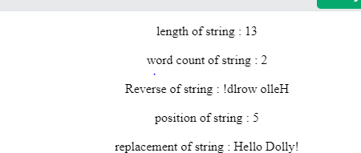

1. **PHPoperators**

<!DOCTYPEhtml>

<html>

<body>

<center>

<?php

$x =10;

$y = 6;echo"************************";echo"</br>";

echo"PHP Arithmetic Operators";echo"</br>";echo"************************";echo"</br>";

echo $x + $y;//additionecho"</br>";

echo $x - $y;// subtractionecho"</br>";

echo $x * $y;//multiplicationecho"</br>";

echo $x / $y;//divisionecho"</br>";

echo $x % $y;//modulusecho"</br>";

echo $x ** $y;//Exponentiationecho"</br>";echo"************************";echo"</br>";

echo"PHP Assignment Operators";echo"</br>";echo"************************";echo"</br>";

echo $x = $y;echo"</br>";echo $x += $y;echo"</br>";echo $x -= $y;echo"</br>";echo $x *= $y;echo"</br>";echo $x /= $y;echo"</br>";echo $x %= $y;echo"</br>";

echo"************************";echo"</br>";

echo"PHP Comparison Operators";echo"</br>";echo"************************";echo"</br>";

echo "$x === $y";echo"</br>";

echo "$x != $y";echo"</br>";echo "$x <> $y";echo"</br>";echo "$x !== $y";echo"</br>";echo "$x > $y";echo"</br>";echo "$x < $y";echo"</br>";echo "$x >= $y";echo"</br>";echo "$x <= $y";echo"</br>";

echo"$x <=>$y";

?>

</center>

</body>

</html>

**OUTPUT**

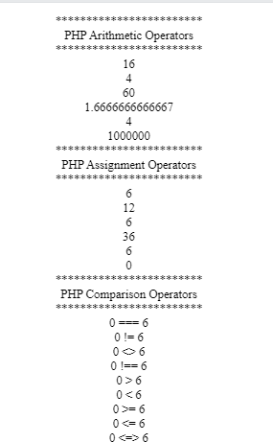

**NAMEOFTEACHER:**

### DATE:

**SIGN**



**SANDIPUNIVERSITY,SIJOUL**

# SchoolofComputerScience& Engineering

### NameofStudent: PRN:

**DateofPerformance: DateofCompletion:**



**ExperimentNo.:06**

**Title:**DesignawebpageusingPHPtodemonstrate conditionalstatement andloops**.**

**Objective:**A simpleweb pagethat includePHP if if–else,elseif,switch,forloop, whileloop.

### THEORY:

**PHPConditionalStatements**

Very often when you write code, you want to perform different actions for different conditions. You can useconditionalstatementsinyour codeto dothis.

InPHPwehavethefollowingconditionalstatements:

***ifstatement****-*executessomecodeifoneconditionistrue

***if...elsestatement****-*executessomecodeifaconditionistrueandanothercodeifthatconditionisfalse

***if...elseif...else statement*** -executesdifferentcodesformorethantwoconditions

***switchstatement****-*selectsoneofmanyblocksofcodetobeexecuted

**PHPLoops**

Often when you write code, you want the same block of code to run over and over again a certain number oftimes.So, insteadofadding severalalmostequalcode-linesinascript, we canuse loops.

Loopsareused toexecutethesameblock ofcodeagainandagain,aslong asacertainconditionistrue.

InPHP,wehavethefollowinglooptypes:

***while*** *-*loopsthrougha block of code aslong asthespecifiedconditionistrue

***do...while -*** loops through a block of code once, and then repeats the loop as long as the specified condition istrue

***for****-*loopsthrougha blockofcodea specifiednumberoftimes

***foreach****-* loopsthrough ablock ofcodefor eachelementin anarray

### CODE:

1. **ConditionalStatements**

<!DOCTYPEhtml>

<html>

<body>

<center>

<?php

$t=date("H");

echo "<p>The hour (of the server) is " . $t;echo"</br>";

echo "and will give the following message:</p>";if($t < "10") {

echo"Haveagood morning!";

}elseif ($t< "20"){

echo "Haveagood day!";

}else {

echo "Haveagood night!";

}

echo"</br>";

//switchstatement

$favcolor="red";

switch ($favcolor) {case"red":

echo "Your favorite color is red!";break;

case"blue":

echo "Your favorite color is blue!";break;

case"green":

echo "Your favorite color is green!";break;

default:

echo"Yourfavoritecolor isneitherred, blue,nor green!";

}

?>

</center>

</body>

</html>

**OUTPUT**

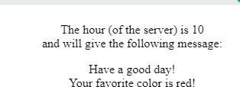

1. **PHP loops:**

<!DOCTYPEhtml>

<html>

<body>

<center>

<?php

//do while loop

echo "**********************<br>";echo "Vlaue of x using do while loop <br>";echo"**********************<br>";

$x=1;

do {

echo"Thenumber is:$x<br>";

$x++;

}while ($x <=5);

//forloop

echo "**********************<br>";echo "Vlaue of y using for loop <br>";echo "**********************<br>";for($y =0; $y<=10; $y++) {

echo"Thenumberis: $y<br>";

}

echo "**********************<br>";echo "Vlaue of y using foreach loop <br>";echo"**********************<br>";

$colors=array("red", "green", "blue","yellow");

foreach ($colors as $value) {echo"$value<br>";

}

?>

</center>

</body>

</html>

**OUTPUT**

**********************Vlaueof xusingdowhileloop

**********************Thenumber is:1

## The number is: 2The number is: 3The number is: 4Thenumberis:5

**********************Vlaueof yusingfor loop

## **********************Thenumber is:0

The number is: 1The number is: 2The number is: 3The number is: 4The number is: 5The number is: 6The number is: 7The number is: 8The number is: 9Thenumber is:10

## **********************Vlaueof yusingforeachloop

**********************red

## greenblueyellow

### NAMEOFTEACHER:

**DATE:**

**SIGN**



**SANDIPUNIVERSITY,SIJOUL**

# SchoolofComputerScience&Engineering

### NameofStudent: PRN:

**DateofPerformance: DateofCompletion:**



**ExperimentNo.:07**

**Title:**Webserverinstallationandconfiguration

**Objective:**Installationandconfigurationofanywebserverlike IIS,Apache,XAMP.

**THEORY:**

**XAMPP** is an open-source, cross-platform web server that consists of a web server, MySQL databaseengine, and PHP and Perl programming packages. It is compiled and maintained by Apache. It allowsusers tocreate WordPresswebsitesonlineusinga localwebserverontheir computer. ItsupportsWindows,Linux, and Mac.

It is compiled and maintained by Apache.Theacronym XAMPPstands for;

X – [cross platform operating systems] meaning it can run on any OS Mac OX , Windows , Linux etc.A– Apache– this is the web server software.

M – MySQL – Database.P –PHP

P–Perl–scriptinglanguage

Developers describe Microsoft IIS as "A web server for Microsoft Windows". ***Internet InformationServices (IIS)*** for Windows Server is a flexible, secure and manageable Web server for hosting anythingon the Web. From media streaming to web applications, IIS's scalable and open architecture is ready tohandle themost demanding tasks.

### HowtoInstallXAMPP

WelookintostepbystepprocesstoinstallXAMPPforWindows.ForOtherOperatingSystems,XAMPPinstallation steps aresimilar.

### Step 1:Download XAMPP

ClickheretoXAMPPdownload forWindows:<https://www.apachefriends.org/download.html>

### Step 2:StartInstallation

XAMPPInstallationisjustlikeinstallinganyotherwindowsprogram.Therearehowever,afewthingsthat wemust note.

### Step3:Runthesetup

Double-clickthedownloadedfileto launchtheinstaller.

### Step4:Runthesetup

ClicktheOKbutton.

### Step5:Runthesetup

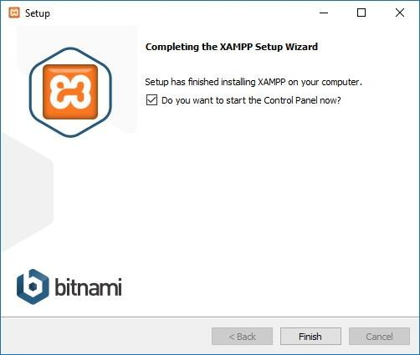ClicktheNextbutton.

### Step 6

ClicktheNextbutton.

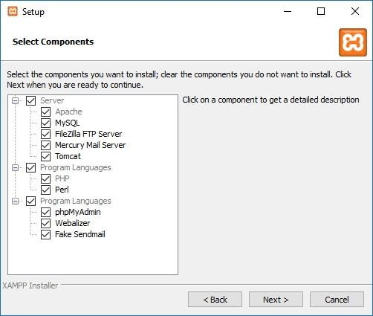

### Step7

Usethe defaultinstalledlocation.(Or choose anotherfolder toinstallthe softwareinthe “Selecta folder”field.)

### Step 8

ClicktheNextbutton.

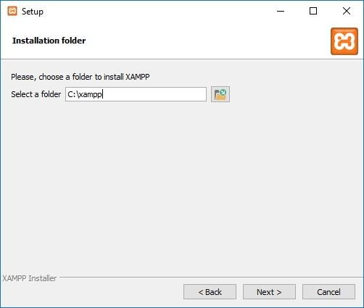

### Step 9

SelectthelanguagefortheXAMPPControl Panel.

### Step 10

ClicktheNextbutton.

### Step 11

CleartheLearnmore aboutBitnamiforXAMPPoption.

### Step 12

ClicktheNextbutton.

### Step 13

ClicktheNextbuttonagain.

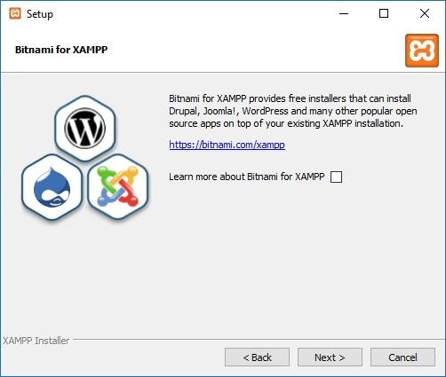

### Step14

Click the Allow access button to allow the app through the Windows Firewall (if applicable).Clickthe Finish button.

Onceyoucompletethesteps,theXAMPPControlPanelwilllaunch,andyoucanbeginthewebserverenvironmentconfiguration.

### ConfigureXAMPPonWindows10

TheXAMPPControlPanelincludesthreemainsections.IntheModulessection,youwillfindallthewebservices available. Youcan start each service by clicking theStartbutton.

When you start some of the services, including Apache and MySQL, on the right side, you’ll also see theprocess ID (PID) number and TCP/IP port (Port) numbers that each service is using. For example, bydefault,Apacheuses TCP/IP port80 and 443, whileMySQLuses TCP/IP port3306.

You can also click the Admin button to access the administration dashboard for each service and verifythateverything is working correctly.

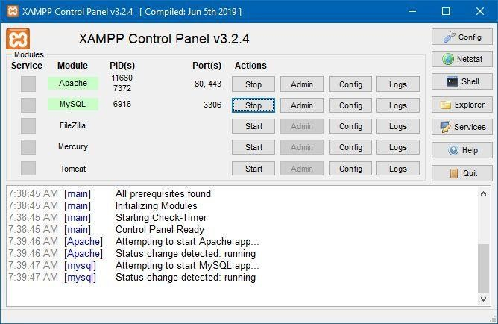

XAMPPControlPanel

Ontherightside,thereisalistofbuttonstoconfigurevariousaspectsofthecontrolpanel,includingtheConfigbutton to configurewhich modules willautomatically start whenyou launch XAMPP.

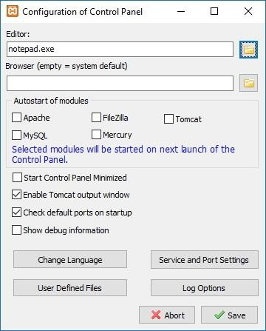

ClickingtheNetstartbuttonwillgiveyoualistofservicescurrentlyaccessingthenetwork,includingTCP/IPaddress and portand processIDinformation.

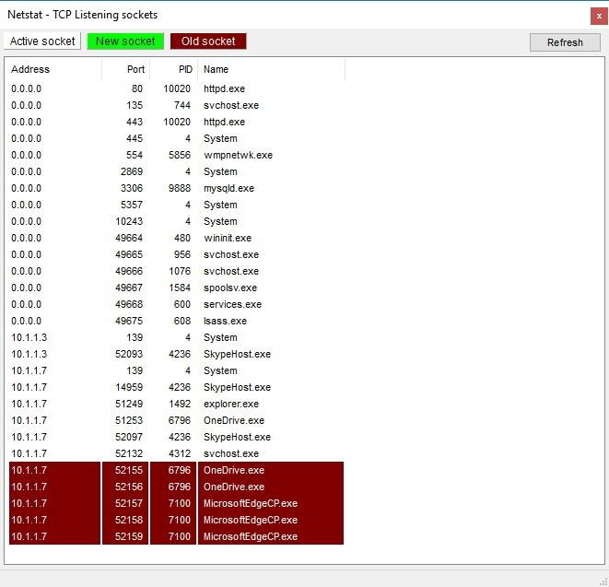

Netstat

Inaddition,therearealsoquickaccessbuttonsfromthecontrolpaneltoopentheshellcommand-lineutility,XAMPPinstallation folder, services, andclosethe app.

Lastly,yougetthelogssectiontoglanceatwhathappenseverytimeyoustartamoduleorchangeasetting.Also, thisis thefirst placeto lookwhen something isn’tworking.

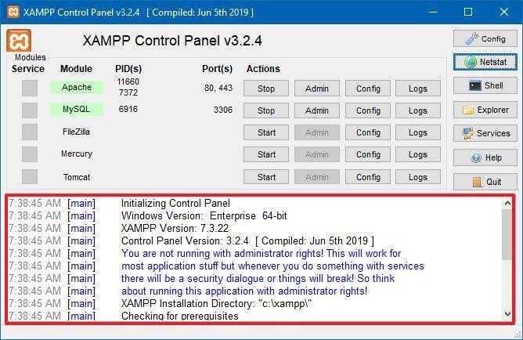

XAMPPControlPanellogs

The default settings should work for most people using XAMPP to create a testing environment to run awebsite. However, depending on your setup configuration, you may need to change the Apache server’sTCP/IPport number, the databaseupload size, or setthepassword for phpMyAdmin.

### NAMEOFTEACHER:

**DATE:**

**SIGN**



**SANDIPUNIVERSITY,SIJOUL**

# SchoolofComputerScience&Engineering

### NameofStudent: PRN:

**DateofPerformance: DateofCompletion:**



**ExperimentNo.:08**

**Title:**Designawebpage usingPHPtodemonstrateMySQLconnectivity.

**Objective:** Simple web pages that include PHP MySQL connect, create DB/Table, insert into, select, update anddelete

**THEORY:**

BeforeyoustartbuildingPHPconnectiontoMySQLdatabaseyouneedtoknowwhatPHPMyAdminis. It’s a control panel from where you can manage the database that you’ve created. Open your browserandgo to localhost/PHPMyAdminor click “Admin” inXAMPP UI.

WhenyoufirstinstalledXAMPP,itonlycreatedtheusernameforittobeaccessed,younowhavetoadd a password to it by yourself. For this, you have to go to User account where the user is the same astheoneshown in this picture:

change password database

NowclickEditprivilegesandgotoChangeAdminpassword,typeyourpasswordthereandsaveit.Rememberthis passwordas it willbeused to connect toyourDatabase.

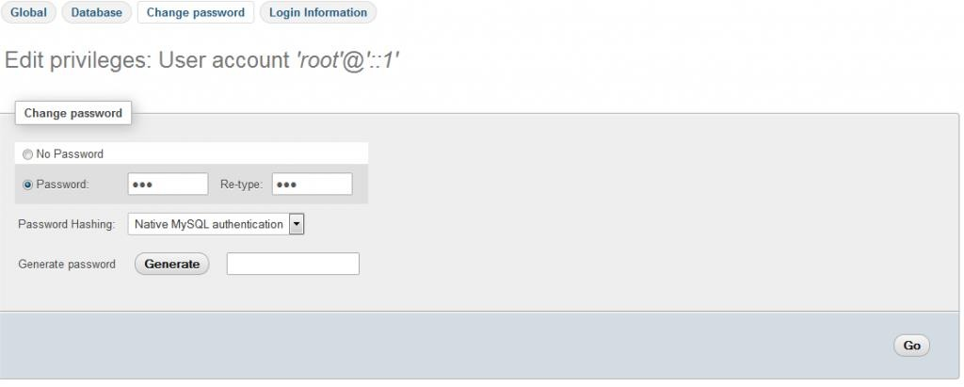

Note:Itisnotnecessarytochangethepasswordtoaccessdatabasesonthelocalhost.Itisagoodpractice and that is whywehaveused apassword.

### CreateDatabase:

Nowreturn tothehomepageof PHPMyAdmin.Click theNew buttonto create anew database.

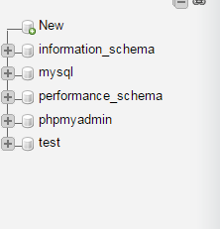

In the new window, name your database as per your need, I am naming it “practice”. Now selectCollation as utf8_general_ci, as we are using it for learning purposes and it will handle all of our queriesand data that will be covered in this tutorial series. Now click on Create and your database will becreated.

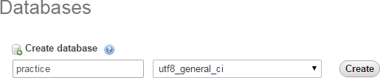

The newly created database will be empty now, as there are no tables in it. I will be covering that in theupcoming series where we will learn how to create tables and insert data in it. In this tutorial, we aregoingto connect this databasetolocalhost usingPHP.

tables in database

### CreateaFolderin htdocs:

Now, locate the folder where you installed XAMPP and open the htdocs folder (usually c:/xampp).Createanewfolderinsidec:/xampp/htdocs/andnameit“practice”wewillplacewebfilesinthisfolder. Why we have created a folder in htdocs? XAMPP uses folders in htdocs to execute and run yourPHPsites.

Note:Ifyou areusingWAMP, thenaddyour practicefolderin c:/wamp/wwwfolder.

### CreateDatabaseConnection FileIn PHP

Create a new PHP file and name it db_connnection.php and save it. Why am I creating a separatedatabase connection file? Because if you have created multiple files in which you want to insert data orselectdata fromthedatabases,youdon’tneed towritethe code fordatabaseconnection everytime.

<?php

functionOpenCon()

{

$dbhost="localhost";

$dbuser="root";

$dbpass= "1234";

$db="example";

$conn=new mysqli($dbhost,$dbuser, $dbpass,$db)or die("Connectfailed: %s\n".$conn->error);

return$conn;

}

functionCloseCon($conn)

{

$conn-> close();

}

?>

Hereis theexplanation of thevariablethatwehaveused in our db_connectionfile:

$dbhostwill bethe host whereyour server isrunning itis usually localhost.

$dbuser will be the username i.e. root and $dbpass will be the password which is the same that you usedtoaccess yourPHPMyAdmin.

$dbnamewill bethe nameof yourdatabasewhichwehave created inthis tutorial.

You just have to include it by using PHP custom function include (include ‘connection.php’) on the topof your code and call its function and use it. It also helps when you are moving your project locationfrom one PC to another and you have to change the values on the single file and all the changes will beappliedto all theotherfiles automatically.

### CreateanewPHPfiletocheckyourdatabaseconnection

CreateanewPHP filetoconnect toyourdatabase.Name it index.phpand addthis codeinthis file.

<?php

include'db_connection.php';

$conn=OpenCon();

echo "Connected Successfully";CloseCon($conn);

?>

### Run it!

Nowopenyourbrowser andgotolocalhost/practice/index.phpandyoushouldseethisscreen:

connection successfully 

### ConfirmationMessage

Congratulations!You’vesuccessfullyconnectedyourdatabasewithyourlocalhost!Ifyouarenotabletoseethis screen, then checkif you havedoneeverythingright in yourdb_connection.php file.

### NAMEOFTEACHER:

**DATE:**

### SIGN